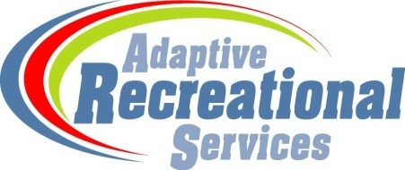
600 North German Street
New Ulm, Minnesota 56073
507-217-0383
arsnu@newulmtel.net
www.nuars.org

ASSUMPTION OF RISK AND WAIVER OF LIABILITY RELATED TO COVID-19
Given an extremely contagious virus and pandemic, ARS cannot guarantee that participants in our program will avoid becoming exposed to and infected by COVID-19. Further, attending our program could increase the risk of contracting COVID-19. Assumption of Risk: By signing this agreement, I acknowledge the contagious nature of COVID-19 and voluntarily assume the risk that the undersigned participant may be exposed to or infected by COVID-19 by attending this program. I understand that such exposure or infection may be very serious and result in personal injury, illness, disability, and even death. It is my choice to participate in this program, and/or to send my participant to this program, knowing that attending this program may increase the risk of becoming exposed to and infected by COVID-19.
I understand and appreciate the risk of becoming exposed to and infected by COVID-19 as part of attending the program.
I acknowledge that exposure to COVID-19, injury, illness, disability, and even death may result from the actions, omissions, or negligence of myself and others, or the actions, omissions or negligence of ARS including but not limited to its management, employees, and volunteers, or the fault of program participants and their families.
I voluntarily agree to assume all of the risks outlined in this form including contracting COVID-19, and the undersigned accepts sole responsibility for any injury or illness to the participant or myself. This risk includes illness, injury, disability and death, and all associated losses and expenses of any kind that I or the participant may experience or incur.
Waiver: In consideration of being permitted to participate in ARS programs I, for myself, and on behalf of the participant, hereby release, agree not to sue, discharge, and hold harmless, ARS, its officers, employees, agents, and representatives, from all claims, actions, damages, costs or expenses of any kind relating to COVID-19. I understand and agree that this release includes any and all claims based on the actions, omissions, or negligence of ARS, its officers, employees, agents, or representatives.
Indemnification and Hold Harmless: I also agree to indemnify, defend, and hold harmless ARS and its officers, employees, agents and representatives from any and all claims, actions, costs, expenses, damages and liabilities, including attorney’s fees, relating to any claim of exposure, infection, injury or illness concerning COVID-19 arising from participation in the listed program or activity.

This assumption of risk, waiver and agreement applies even if the undersigned asserts the program was at fault for not taking greater precautions to manage exposure or infection from COVID-19 and the pandemic. Participants and their families assume the risk of illness and injury, as outlined in this document.

