|  |  |  |  |  |  |  |
| --- | --- | --- | --- | --- | --- | --- |
| **Sunday** | **Monday** | **Tuesday** | **Wednesday** | **Thursday** | **Friday** | **Saturday** |
|  |  |  |  | 1  ARS on the Go  Drive-By  6:30pm-7:00pm  Community Center Parking Lot | 2 | **3**  Maker Fest downtown  New Ulm  10am-3pm  Music on the steps  State Street Theater  2pm-6pm  **food trucks too! |
| **4** | **5** | **6** | **7** | **8** | 9 | 10 |
| **11** | **12** | 13 | **14** | **15** | 16 | **17** |
| 18 | **19** | **20** | **21** | **22** | 23 | 24 |
| **25** | **26** | **27** | **28** | **29**  ARS on the Go  Drive-By  6:30pm-7:00pm  Community Center Parking Lot | 30 | 31  C:\Users\ARS\AppData\Local\Microsoft\Windows\INetCache\IE\R4OAOPGH\happy-halloween-1506961290RMi[1].jpg |

**October 2020 Newsletter**

*Check us out on Facebook, we will be posting pictures from our events. Facebook will also have information about up coming events.



*As always, please remember to check our website for updates. [www.nuars.org](http://www.nuars.org)

Note from Eliza with Jesus Cares Ministry at MLC: *Jesus Cares, the Saturday morning Bible study at St Paul's church, will continue by mail this fall. If you would like to receive weekly devotions and story sheets, please send your mailing address to Eliza by email:* [*punzlec@mlc-wels.edu*](mailto:punzlec@mlc-wels.edu) *or text: 920 243-8054 or call St Pauls at 507 354-3641.*

**Coordinator’s Note:**! It’s time to order T-Shirts. Each participant will be able to order ONE shirt free of charge. If you want both colors, the second shirt will be $5.00. If you are a parent, family member, house staff, PCA or a friend of ARS and would like to order a shirt, I am asking for a free will donation of no less than $5.00 per shirt. I will need to collect all money before the shirt order is placed. Cash or Check made out to ARS will be accepted. I am keeping the order open until October 29th, so you can bring money to either of the ARS on the Go events in October. You can also send checks to written out to ARS at **my home address of Karrie Borchert, 405 South Broadway Street, New Ulm, MN 56073.** Here are the colors chosen and the design of the shirt: The shirt says ARS on the Go 2020 on top of the car with Doing Our Part to Stay Safe, Smart and Social underneath the car. The colors are Gold and Red tie-dye burst. Sizes are Small, Medium, Large, Extra Large, 2XL, 3XL and 4XL. Please call me with any questions about shirt orders.

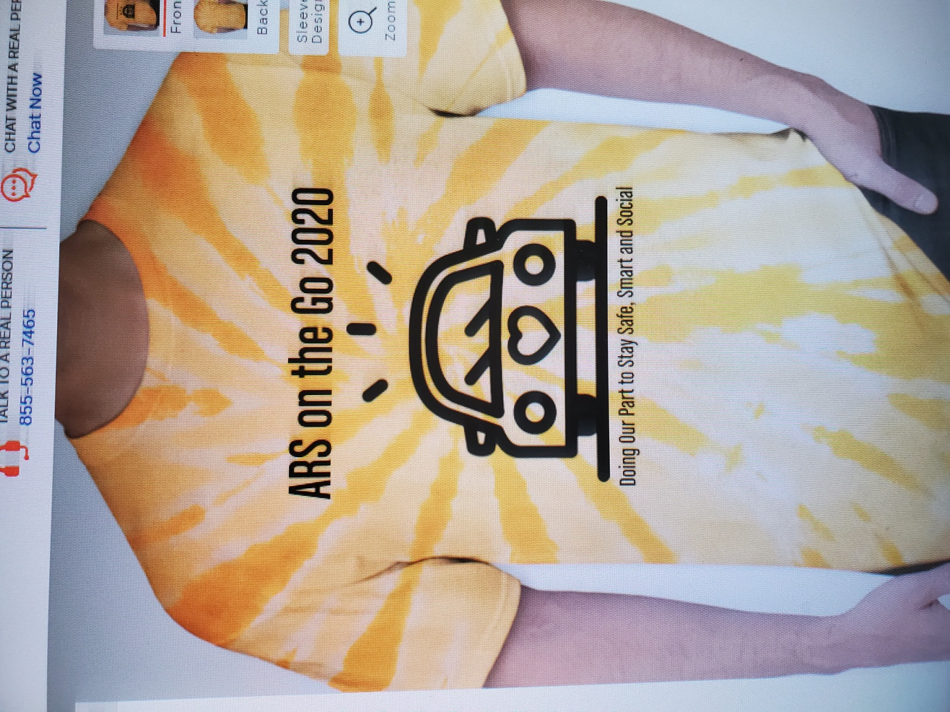 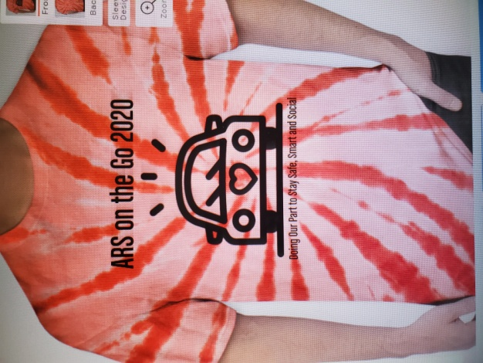

|  |
| --- |
|  |

**507-217-0383**

[**arsnu@newulmtel.net**](mailto:arsnu@newulmtel.net)

[**www.nuars.org**](http://www.nuars.org)

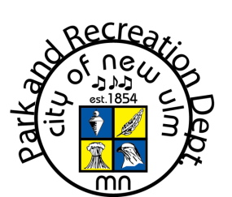****



600 N German Street

New Ulm MN 56073

507.217.0383

[arsnu@newulmtel.net](mailto:arsnu@newulmtel.net)

 

[www.nuars.org](http://www.nuars.org)

[arsnu@newulmet.net](mailto:arsnu@newulmet.net)

507.217.0383