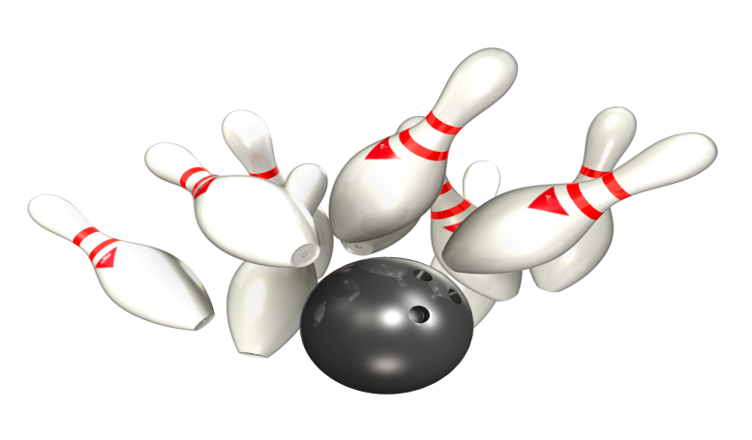

Cash Back Bowling Fundraiser

for

Adaptive Recreational Services

WHEN: SATURDAY, January 18, 2020 from 10:30 a.m. to 12:30 p.m.

WHERE: Concordia Lanes in New Ulm, Minnesota

COST: Each game of bowling is $3.99 plus tax ($4.30)

Rental shoes are $2.25 (or bring your own)

\*\*\*these are the quotes given in December of 2019\*\*\*\*prices may change without notice

WHAT DO I HAVE TO DO SO ARS GETS A DONATION?

It’s simple! For each game bowled, Adaptive Recreational Services (ARS) will receive $3.00 Cash Back. This fundraiser requires at least 12 bowlers to qualify, so we would love to have you join us. This fundraiser is not just for ARS members, but for everyone in the area who loves to bowl. Please bring your family and friends to this great event and help raise programming dollars for ARS. Please contact ARS Coordinator, Karrie Borchert, with any questions at 507.217.0383 or email at [arsnu@newulmtel.net](mailto:arsnu@newulmtel.net).

Thank-you to Concordia Lanes for this awesome fundraising idea!.